

WIMBLEDONS CHAMPIONS ANALYSIS

Project Report

Quarter II(Year2)

Submitted by

Bhuvann.v Koushik G

E0420018 E0420012

In partial fulfilment for the award of the mark of

CSE 260 DATA VISUALIZATION TOOLS AND TECHNIQUES

in

COMPUTER SCIENCE

(Dept)

Sri Ramachandra Faculty of Engineering and Technology

Sri Ramachandra Institute of Higher Education and Research, Porur, Chennai -600116,Nov, 2021

Table of Contents

Title Page.No

1.Introduction 3

2.About Tableau 4

3.Problem statement 5

4.About the dataset 6

5.Tools and Technologies 7

6.Finding questions 8

7.Implementation 9-12

8.Conclusion 13

9. Reference 13

Introduction to Data Visualization

Data visualization is the graphical representation of information and data. By using visual elements like charts, graphs, and maps, data visualization tools provide an accessible way to see and understand trends, outliers, and patterns in data.

Easily graspable information – Data is increasing day-by-day, and it is not wise for anyone to scram through such a quantity of data to understand it. Data visualization comes handy then.

Establish relationships – Charts and graphs do not only show the data but also establish correlations between different data types and information.

Share – Data visualization is also easy to share with others. You could share any important fact about a market trend using a chart and your team would be more receptive about it.

Introduction To Tableau

Tableau is a fastly growing and powerful data visualization tool. Tableau is a business intelligence tool which helps us to analyze the raw data in the form of a visual manner; it may be a graph, report, etc.

Data analysis is very fast with Tableau, and the visualizations created are in the form of worksheets and dashboards. Any professional can understand the data created using Tableau.

Tableau software doesn't require any technical or any programming skills to operate. Tableau is easy and fast for creating visual dashboards.

Data blending is the most important feature in Tableau. It is used when we combine related data from multiple data sources.

Problem Statement

1.To plot graphs using the data set of WIMBLEDONS CHAMPIONS from 1877-2016.

2.Analyzing the dataset to study and review the information about WIMBLEDONS CHAMPIONS.

3. Find Various kinds of graphs and maps in Tableau.

About The Dataset

•Dataset: WIMBLEDONS CHAMPIONS

•Year: 1877-2016

•Source: Tableau open source

•Main Contents:

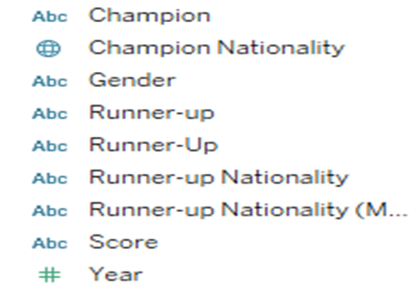

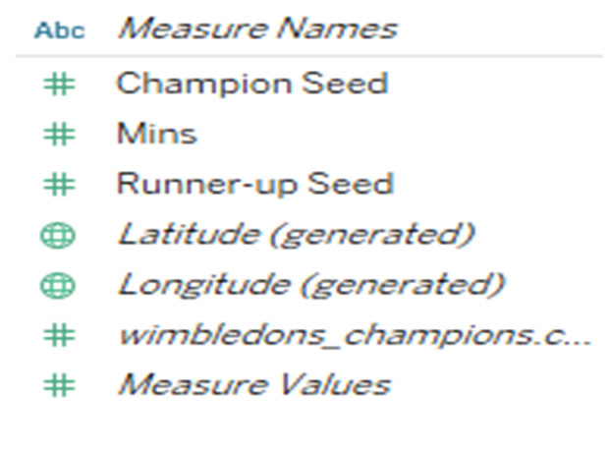

Tools And Technologies

* Tableau



* Microsoft excel



Finding Questions:

•In which year did Maria Sharapova win the Wimbledon cup?

•Which player has won more championships with more champions seed ? (men)

•Which player have won more championships with more champions seed ?(women)

•Which country had the most champions per country gender wise?

•Who are the top 10 champions with more seed?

•What are the champion countries on dates?

•Who are the top 10 Runner-ups with more seed?

•What are the countries with the most Runner-ups?

Implementation

1.In which year did Maria Sharapova win the

Wimbledon cup?

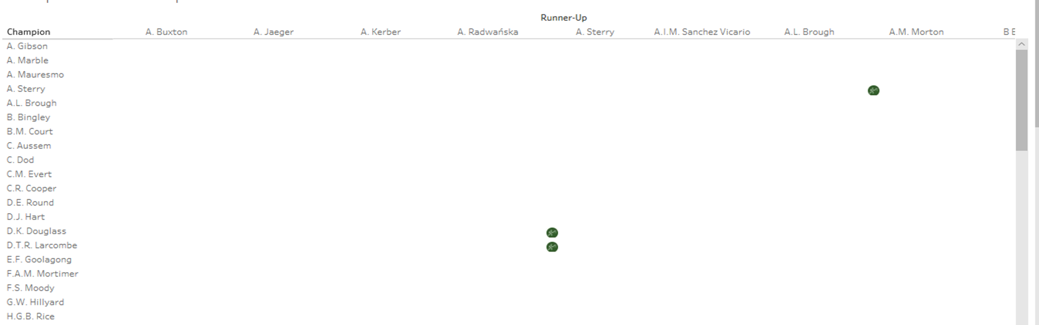

2. Which player has won more championships with more champions seed ? (men)

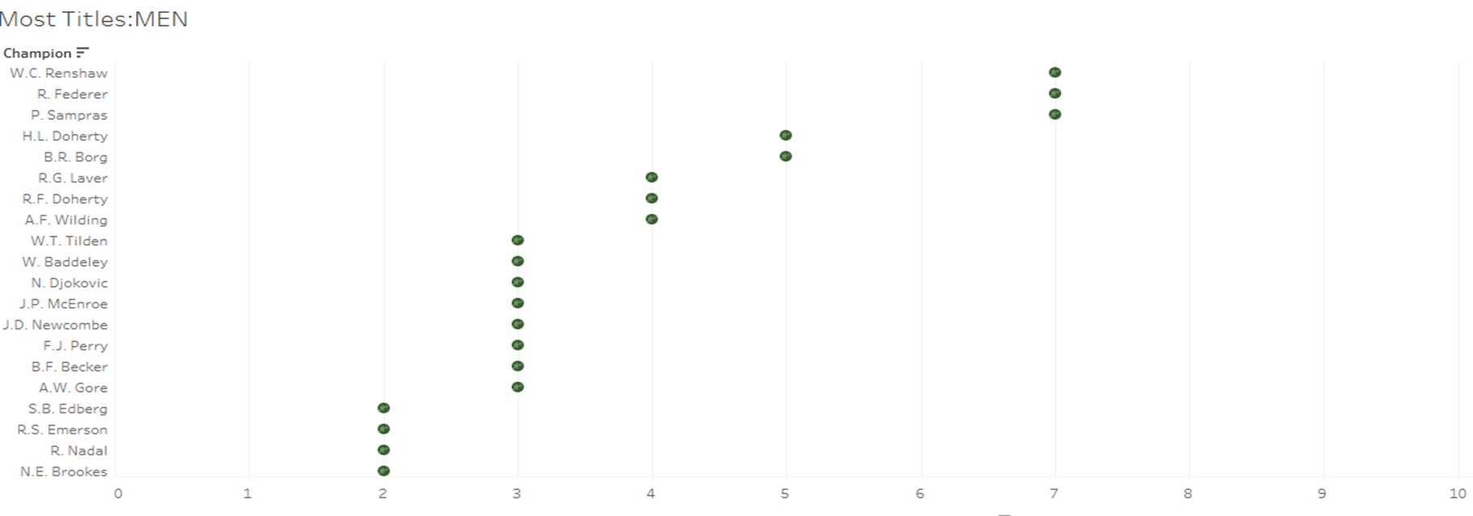

3.Which player has won more championships with more champions seed ?(women)

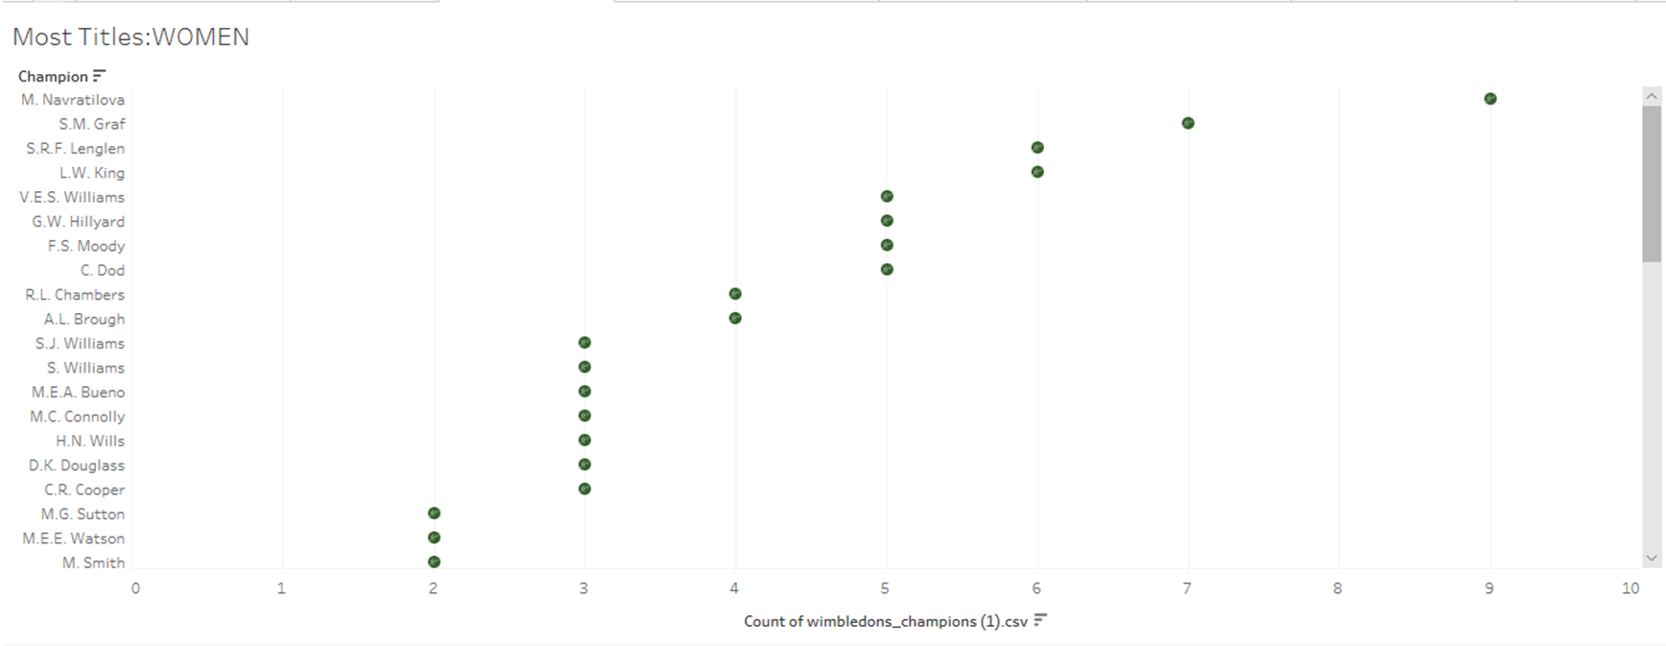

4.Which country had the most champions per country gender wise?

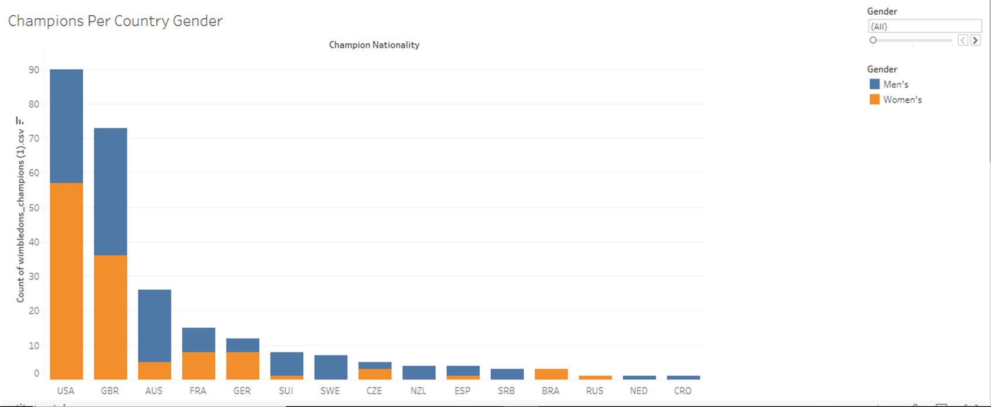

5.Who are the top 10 champions with more seed?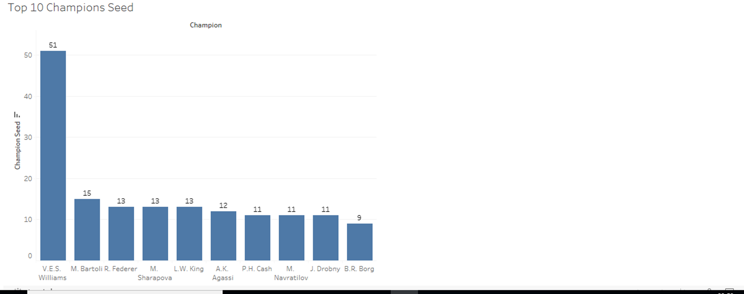

6.What are the champion countries on dates?

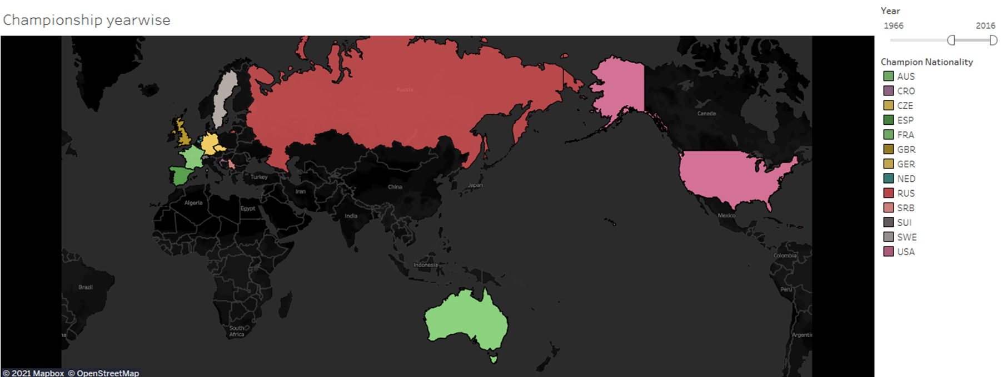

7.Who are the top 10 Runner-ups with more seed?

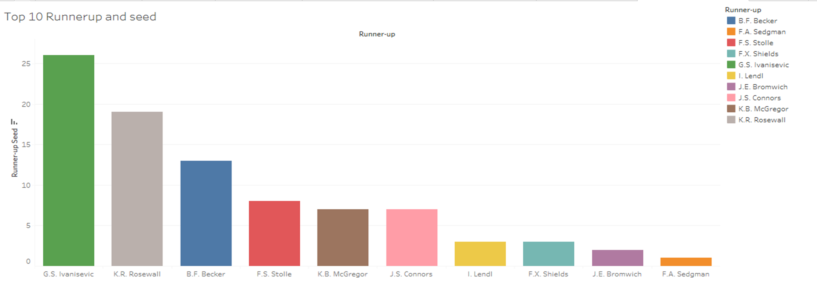

8. What are the countries with the most Runner-ups?

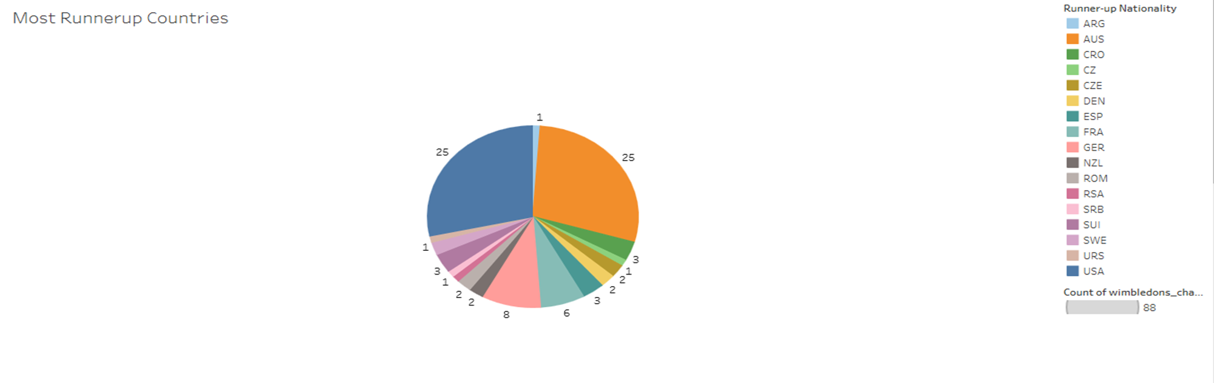

CONCLUSION

Here we conclude that the Wimbledon championships are analysed through Pictorial form, so that we came through different parameters and sets in tableau for easy understanding.

References

•<https://public.tableau.com/en-us/s/resources>

THANK YOU :)